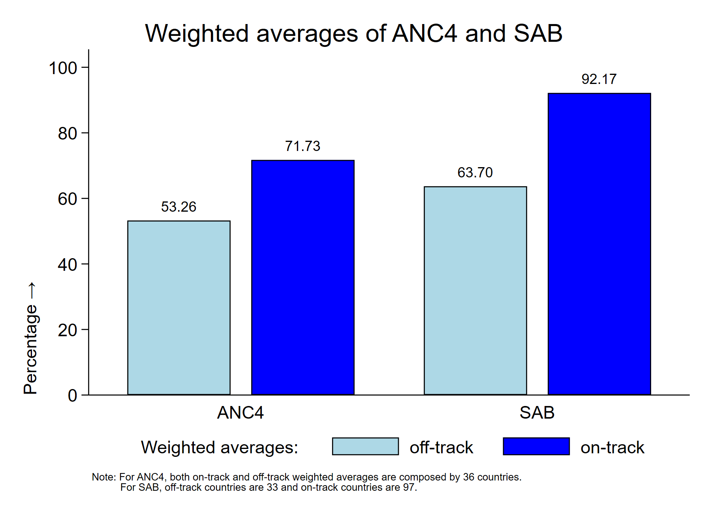
TASK 1: Interpretation of the results
The graph above shows the weighted average of antenatal 4+ (ANC4) visits and skilled birth attendants (SAB) for all countries included in the UNICEF Global Data Repository stratified by on-track and off-track countries. Not surprisingly the percentage for both indices is strongly greater for on-track countries than off-track countries. The rate of SAB for on-track countries is close to 100%. This shows that skilled health professionals assist almost all births in these 97 countries. For this indicator, the gap between off-track and on-track countries is greater than 30%. Therefore, the 33 countries that are still off-track need to strengthen their health systems to reach SDG 3. ANC4 shows a similar trend between on-track and off-track countries. The performance of on-track countries is lower than in the case of SAB with a weighted average of 71.73% and a gap between the two groups of slightly less than 20%.

